The Long-Term Internship Program FY2022
Application Form
Family Name |  |  |  | Given Name |  |  |  |  |  | Organization /  School/Faculty  School Year
Date of Birth |  | (Month / Day / Year) |  |  |  |  |  |  |  | Gender |  |  |  | Nationality
Present Address |  | Zip Code:  Tel：（ ） — e-mail：  Another contact number to reach you on campus during the daytime： ( )
Academic Background  ※Please fill in your subject information after graduating from universities.  Please add rows as necessary. |  | Academic Background
 |  |  |  |  |  |  |  |  | Name of University/School |  | Date of Graduation  (Month / Year)
 |  | Undergraduate
 |  | Graduate
 |  | Graduate
Doctorate degree granted (or expected to be granted)
in _______________________________ (Area of Study) on _____________________________(Month/Year)
 |  | Employment Record
 |  | Month/Year |  |  |  |  |  | Organization
Language |  | Native Language: |  |  |  |  | (Fill in the level of the Japanese Language Exam) |  |  |  | Second Language with proficiency at or above conversation-level
Language Qualification/  Score  (EIKEN, TOEIC, etc) |  | (Month/Year) |  |  |  |  |  |  |  |  | For international applicants, provide details of your status. (under any national programs, government-sponsored, etc.)
 |  | (Month/Year)
Programming Language, Application |  | R, Python, C++, Fortran, STATA, SPSS, Matlab, etc.
Grant Information |  | Are you receiving any grant? (Y/N) |  |  |  | Please provide details of the grant as well as your duties where applicable （RA、TA、JSPS Research Fellowship for Young Scientists, etc.）
Collaborative  Research with Companies, etc. |  |  | Please provide details of the respective roles and responsibilities of the company and the Applicant in the collaborative research. Write down “none” if you have no collaborative research experience.
Internship Experience |  |  | Please provide details of the host organization(s)/institution(s), the period of the internship, and your job description. Write down “none” below if you have no internship experience.

About your interest in Internship
Desired host organizations, department, location
Desired field (if you have in your mind)
Desired period of internship

1. Ambition for the Long-Term Internship (potentially used for screening at the host organization)
Please describe your ambition for the long-term internship, in line with its objectives, with a focus on the following four points. (Less than 500 words)
- Motives and Reason for applying
- Skills / knowledge you are aiming to obtain through the internship program
- Career aspiration after the internship

2. Research Summary up to date (potentially used for screening at the host organization)
Please describe your research to date, focusing on the research contents, the background, the characteristics unique to the research and the current progress, with less than 250 words in plain and brief language. (You can attach graphs/charts)

Self-Assessment (before internship) (to be used as a part of the evaluation process at HIRAKU Operating Council Office)
Please complete the self-assessment for Employability under the Skill Development Function menu in the “Young Researchers’ Portfolio (HIRAKU-PF)” system. Based on your strengths and areas for improvement identified through the exercise, describe the assessment results and the skills/competencies you would like to improve through the internship, with less than 500 words in plain and brief language. Please attach the self-assessment report downloaded from HIRAKU-PF.

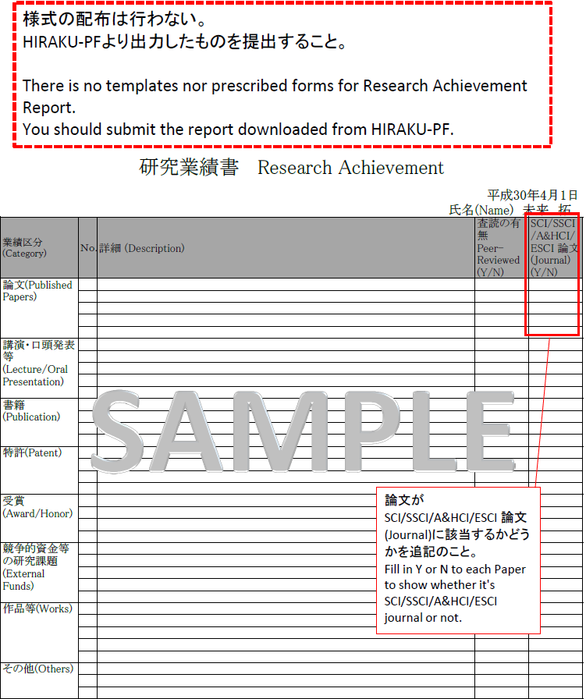
Date: _________________

Letter of Recommendation
for Long-Term Internship Program FY2022 Applicant

I fully understand the objectives of the Program for the Practical Training and Engagement of Innovators and hereby recommend the person named below as the candidate for the subject Long-Term Internship Program.

(Name of the Applicant)

(Signature)

Name:
Title:
Organization/School

Contact Information (TEL/E-mail):

- Your relationship to the Applicant

- Please describe below the applicant’s research attitude, research progress, subject knowledge/skills, and other competencies such as inventiveness/creativity, communication skills, leadership, etc.

- What is the significance of this long-term internship experience to the Applicant?

【Only applicable to HIRAKU Member Organizations】

Letter of Consent

To President of Hiroshima University

With regards to the Long-Term Internship Program participation by __(Name of the Applicant)__, I hereby consent to the following conditions:

Conditions

- The subject Applicant (“the Applicant”) will take the class “Long-Term Internship,” the Common Subject of Graduate School in Hiroshima University, in case he or she is a doctoral student (excluding the master’s program).
- In case the Applicant is a doctoral student (excluding the master’s program), we, as the university he or she belongs to, will enroll him or her into the Personal Accident Insurance for Students Pursuing Education and Research (“PAS”) and the Liability Insurance for Students Pursuing Education and Research (“LSR”) on our own responsibility.
- We will conclude, after consultation, the Memorandum and the Internship Description relating to the Internship under the Program for the Practical Training and Engagement of Innovators with Hiroshima University and the host organization.

Date:

(Signature)
Name of Representative:
Title:
Organization:

Address:

